MCADSV Fiscal Procedures – Vacation Liability Accruals

Vacation Liability

* At the end of each month, run a report from MIP and export it to Excel to calculate the percentages by which vacation liability can be allocated. **Reports>Expanded General Ledger>Employee Earnings Distribution.** Change the dates to the month you want to allocate and export to Excel. (see screen print, report set up)

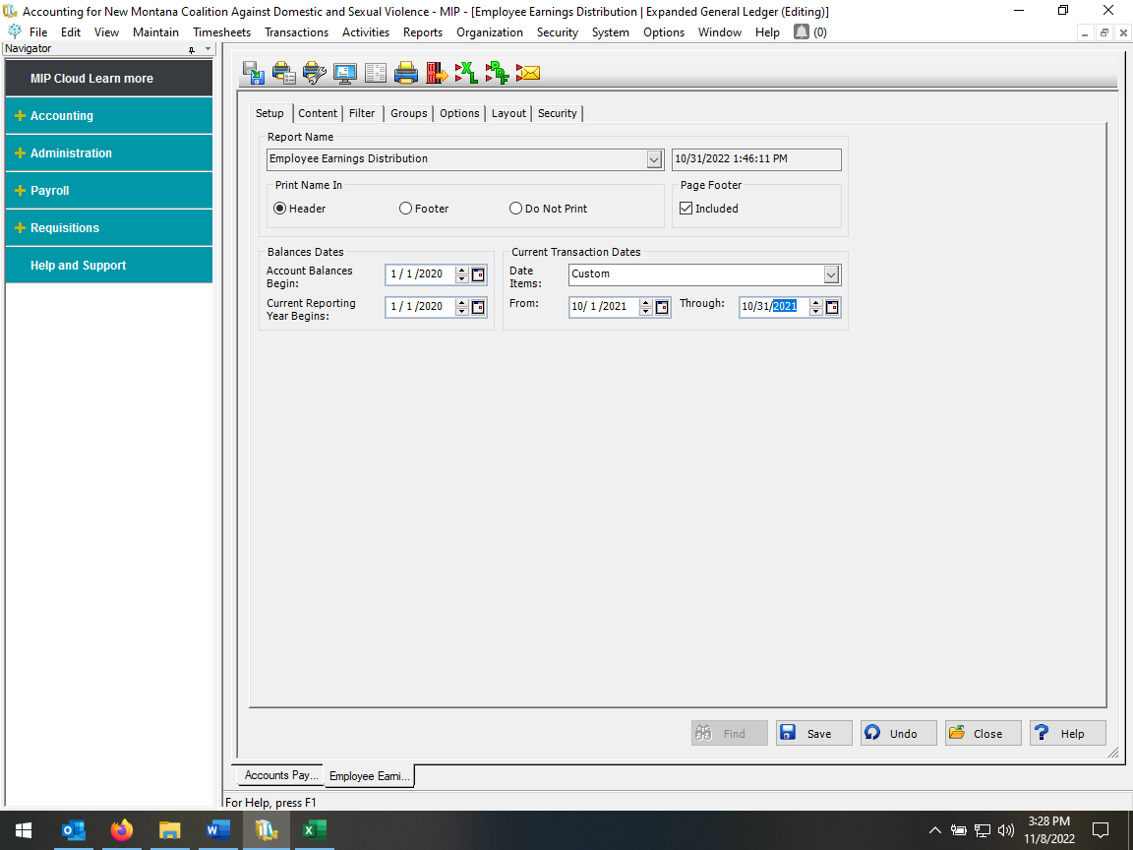

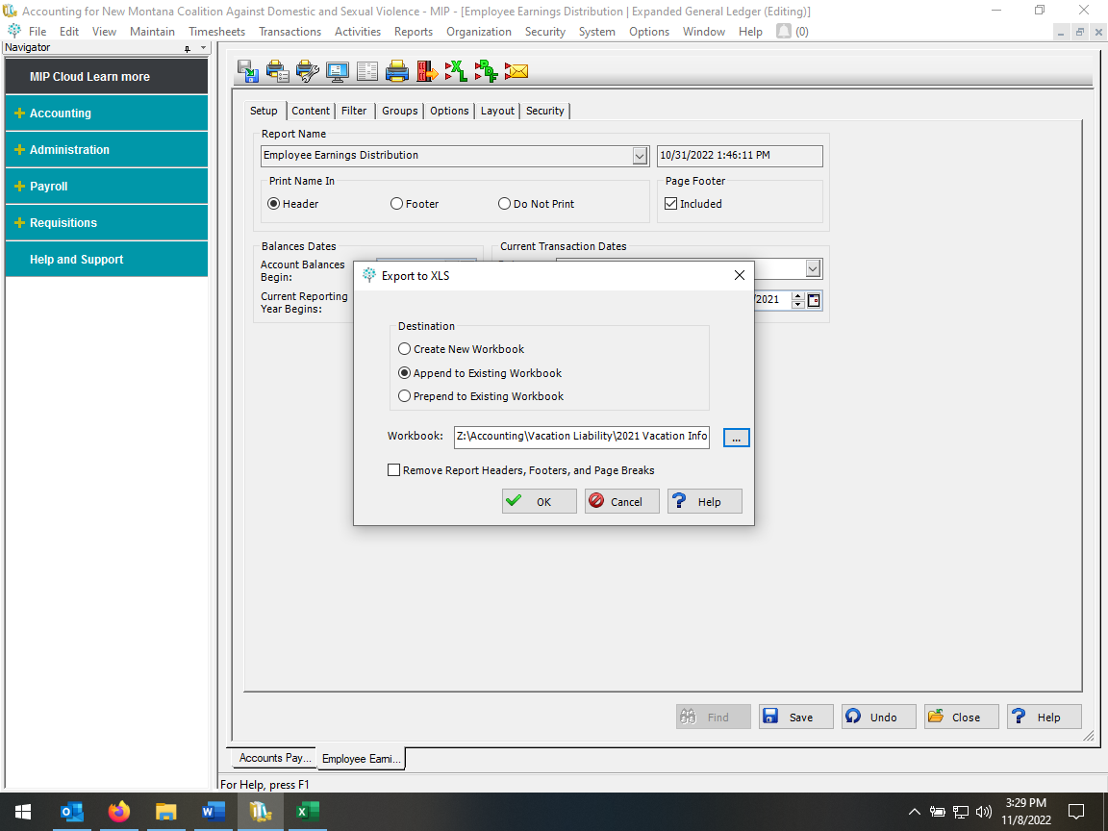

* This will create a new tab for you to label in Excel for the new report data. Save the worksheet so you can continue
* Once in Excel, on the new worksheet, subtotal on ID and sum by Debit. You can delete the Credit column and change it to percent. For each line, divide the debit amount by the total amount for the employee and make sure it adds to 100%. (See sample Excel report with formulas showing)

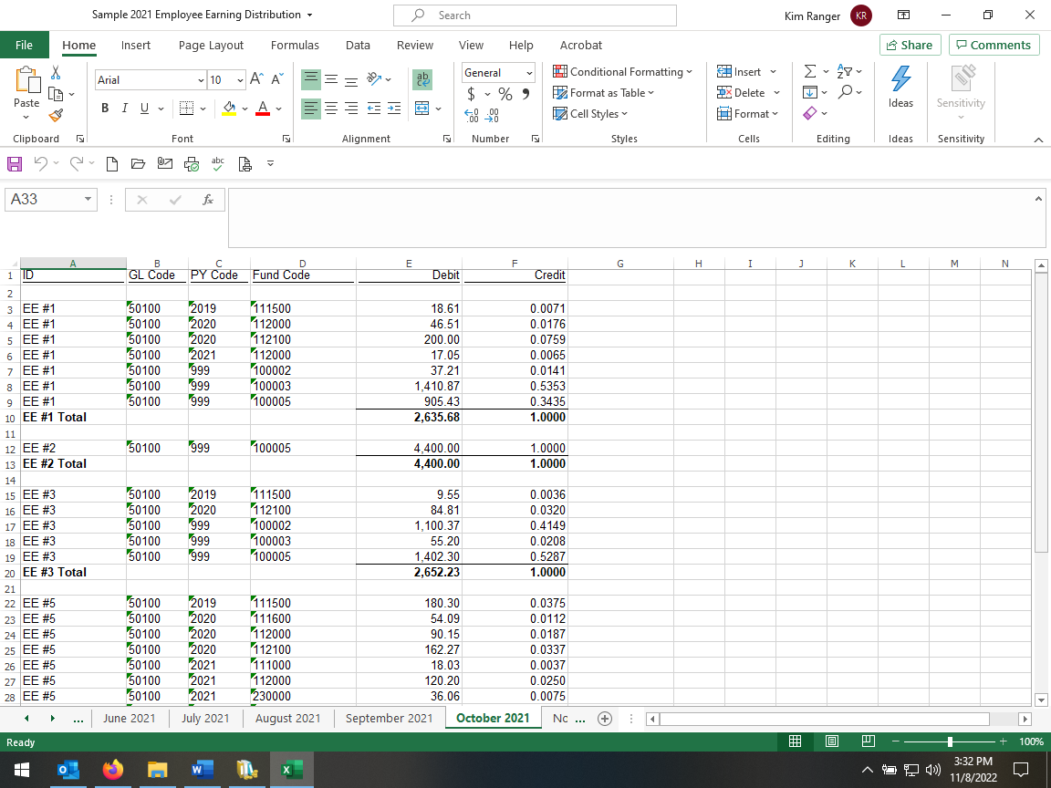

* The percentages are used in the vacation liability report. Share Drive\Accounting\Vacation Liability\20XX Vacation Liability.
* For the column in this report titled Balance Hours (for the new month), use the employee vacation report to enter the total hours remaining for each employee. It is in the same file as mentioned above and is titled Vacation 20XX.

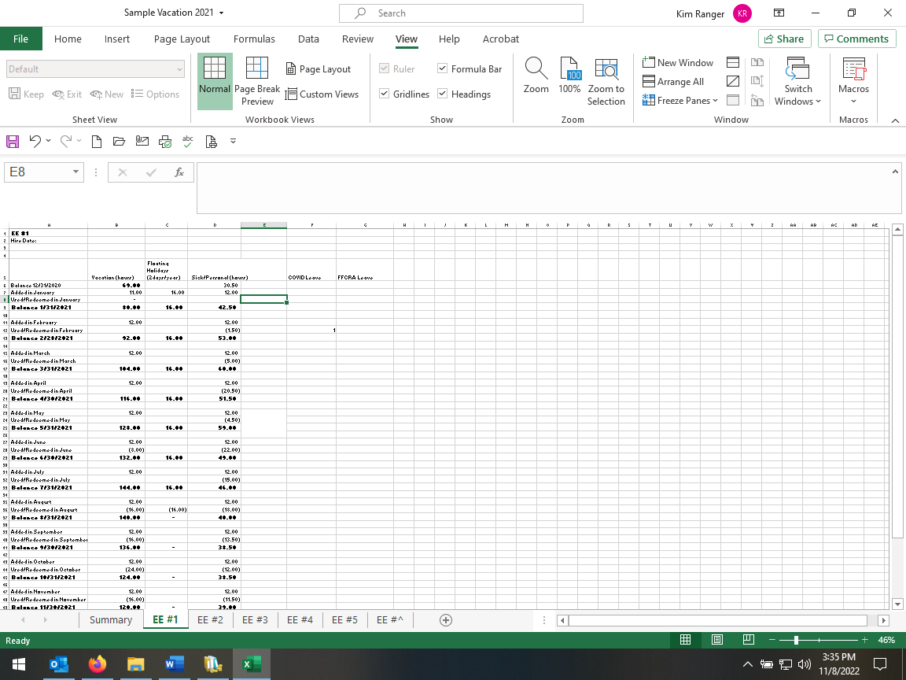

* Once the balance hours have been entered, use the spreadsheet created from MIP data to enter the percentages each employee worked in the different grants. Make sure the Total % is 100% for each. The spreadsheet creates the journal voucher entry for MIP (double check that all formulas are working and include all data). Enter the data in the columns that show the % - like DOJ%.
* Once the spreadsheet is complete, enter the journal voucher into MIP. Give the spreadsheets and Unposted General Ledger Transaction Report to the Administrative Director for review and posting.
* Everything is then filed in the Vacation Liability binder.