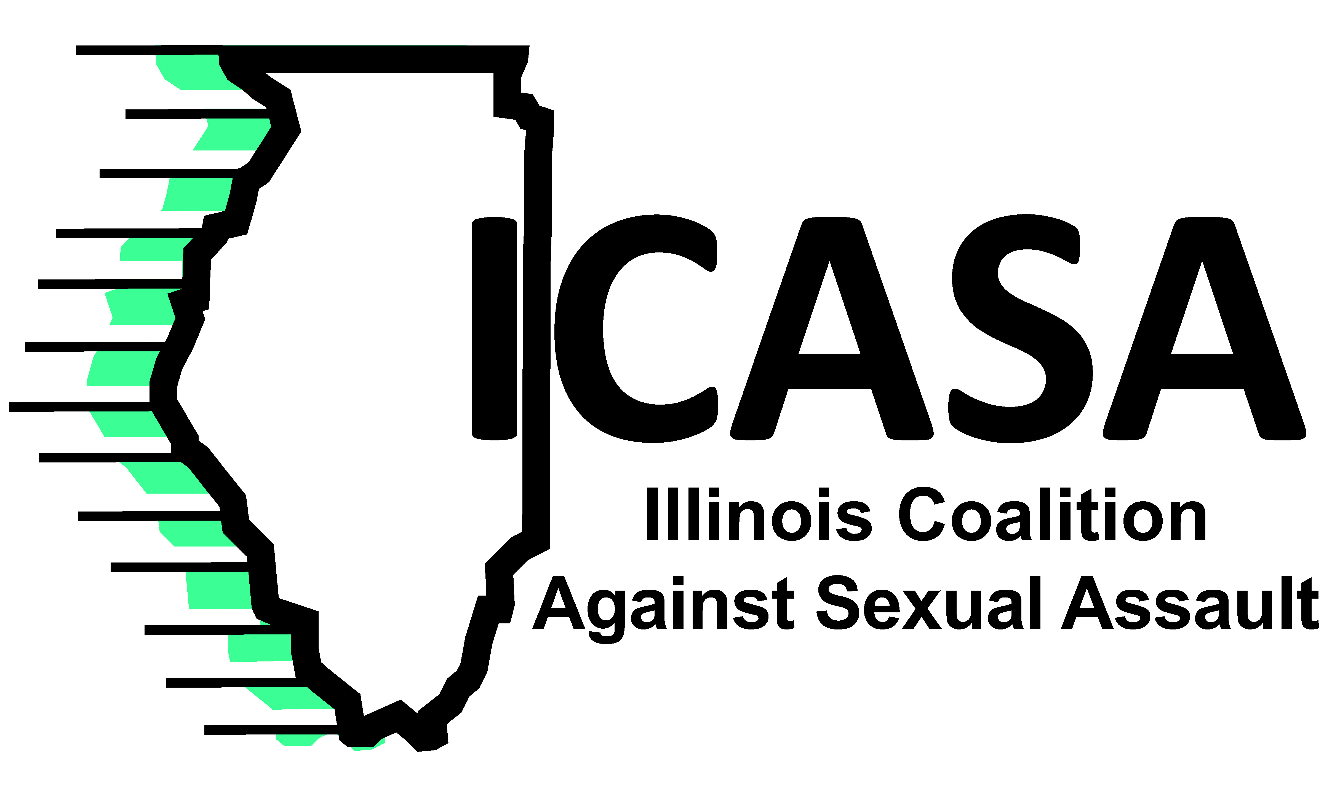

TO: ICASA Certified Centers
FROM: Sarah Beuning, General Counsel
DATE: August 2020
RE: Attorney Referral Packet

Rape crisis centers often receive requests for information about a client, the services that client has received, and even the client’s status or progress in counseling. Sometimes, the steps in responding to those requests are clear. Other times centers need legal assistance to respond. ICASA staff can provide some assistance and guidance, but other issues must be handled by attorneys specifically representing your center. This memo outlines steps rape crisis centers should take to prepare to respond to information requests and subpoenas. This packet provides helpful resources to seek a local attorney to assist your program.

NOW

Find a Local Attorney! Start developing relationships with attorneys in your community. The most important step in adequately protecting your center and your clients is to ensure that you have one or more attorneys prepared to represent you in the event that you need to respond to a request for information on short notice. It is very important that you find and develop a relationship with a lawyer. If you receive a subpoena and have only a few days to respond, you may have a difficult time locating an attorney and getting them up to speed in the short time available.

Share the Attorney Referral Packet with Your Lawyer. Enclosed are materials to share with a local attorney willing to represent you, including:
- A sample cover letter you may personalize and send to the attorney
- A copy of the Confidentiality of Statements Made to Rape Crisis Personnel statute
- A sample Motion to Quash
- Caselaw related to privilege for rape victims
- A law review article related to rape crisis privileges
Meet with your lawyer. Talk about your work and legal needs. Share these materials. Discuss payment options with your attorney. Ask your attorney whether they would be willing to represent your center and file a future motion to quash on a pro bono or reduced fee basis.

WHEN YOU RECEIVE A REQUEST

A request for information can come to a rape crisis center in a variety of forms, including phone calls, letters, or more formal subpoenas. In any of these situations, follow these steps:

- Don’t disclose anything, even the fact that someone is a client at your center, without talking to the client.
- Review the file to determine whether a release of confidential communications has already been signed.
- Talk to the client about whether they want to release information in response to the current request.
- If applicable, explain the difference between a release of Personally Identifiable Information (PII) and a release of confidential communications, which waives privilege.

For privileged information we recommend using the Checklist for a Client Considering Signing a Release available in the ICASA Confidentiality Counts materials online at www.icasa.org in the Members Services section.

IF THE CLIENT WANTS TO WAIVE PRIVILEGE

If the client signs a release for records, you may send a copy of the requested records to the person requesting it. Keep the original documents in the file that your center maintains.

If the client signs a release for testimony, you may call the attorney requesting your testimony at a deposition or hearing. If center staff testifies at a deposition, it is up to the center whether the staff person will have an attorney representing the center at the deposition. It is not necessary to have an attorney for the center unless the center is a defendant, in which case it is imperative that the center have counsel. For guidelines on testifying, see “Testifying in Sexual Assault Cases” by Cynthia Carter also available in the Confidentiality Counts materials online at www.icasa.org in the Member Services section.

Only provide information consistent with ICASA Service Standards.
It is common for centers to receive requests for center staff to do things that are outside the center’s scope of services (e.g. a request to make a recommendation related to custody and visitation). Even if a client signs a release, center staff should only provide information related to existing services, and opinions consistent with the staff member’s role at the center.

IF THE CLIENT DOES NOT WANT TO WAIVE PRIVILEGE

Tell the attorney asking for the information. If the client chooses not to waive their privilege, this information needs to be communicated to the requesting attorney. Many lawyers are not familiar with the Confidentiality of Statements Made to Rape Crisis Personnel statute. A phone call from the center director, or counsel representing the center, may be sufficient for the requesting attorney to withdraw the request.

File a motion to quash. In the event that the requesting attorney does not withdraw the subpoena or request, your center’s attorney will need to file a motion to quash. After it is filed, your attorney will represent your center at a hearing before a judge to argue the motion. The rape crisis privilege in Illinois is very strong and ICASA rape crisis centers have prevailed in protecting clients’ privilege in the past. It is necessary for an attorney to argue this issue on behalf of your center.

HOW ICASA CAN HELP

I am available to provide technical assistance to center staff and to your local attorney in responding to requests for information. Many issues arise repeatedly in this kind of case, so I am happy to work with your center and may be able to provide insight from prior cases involving other rape crisis centers. Please feel free to contact me at (217) 753-4117, or to share my contact information with your counsel.

