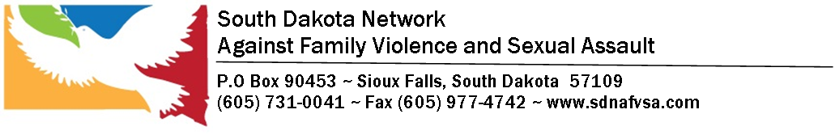
Organizational Chart 2022-2023
Board of Directors- Executive Committee
Co- Chairs: Dawn Sikkink and Lindsey Compton Secretary- Norma Rendon
Vice President – Linda Shroll E-Committee member- Tifanie Petro
Treasurer- Michelle Trent E-Committee member- Ayesha Meer and Tifanie Petro

Executive Director – Krista Heeren-Graber

TA Coordinator West River
Mike McCormick
Grants Compliance Supervisor
Eric Lingen
Director of Program Development and Evaluation
Christy VanDeWetering
Assistant Director
Kathy Rutten
Project Coordinator
Raina Boyum
Financial Director-
Bonnie Tschetter

Grants Project Manager
Olivia Boese
MSW INTERNS
BSW INTERNS
Project Specialist
Sara Kindvall
FAST Coordinator
Tanya Grassel-Krietlow
Office Manager
Vien Hall

Financial Assistant
Lora Ronning

Grants Project Specialist
Annie McMillan

