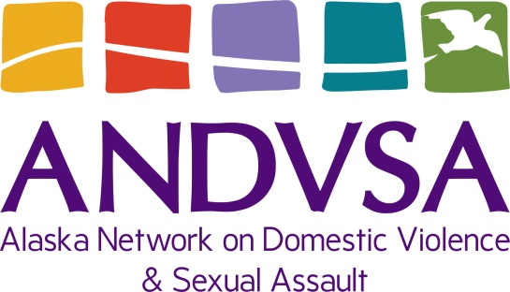
Direct Supervision Load
Executive Director 7
Prevention Director 5
Legal Director 2
Staff Attorney 2
Advocacy Director 3
Administrative Director 3

FY22 ANDVSA Organizational Chart
Juneau Office
Anchorage Office
Sitka Office
State-wide

Organizational Members
23 Programs
l
Communication & Policy Specialist
- FTE
Liz Leonard
Executive Director
- FTE
Brenda Stanfill
Leadership& Diversity Director
- FTE
Rodney Gaskins
Financial Administrator
.80 FTE
Mary Norcross

Legal Office Coordinator
1.0 FTE
Project Director
Legal Services
- FTE
Christine Pate
Advocacy Initiative Director
- FTE
Lauree Morton
Project Director Prevention
- FTE
Rae Romberg
Administrative Director
1.0 FTE
Cindy

Fellow
.50 FTE
Semaite Abiy
Senior Office Coordinator
0.80 FTE
Marjorie John

Senior Staff Attorney
- FTE
Katy Ruff Soden
Advocacy Specialist
- FTE
Christina
Prevention Coordinator
- FTE
Alex
Accounting Tech
1.0 FTE
Ivette

Legal Program Coordinator
- FTE
Mindy Lowrance
Specialized
Trainers

Staff Attorney
1.0 FTE
Cory

Paralegal
1.0 FTE
Jen
Prevention Specialist
2.5 FTE
Doug/Esther/Rinam/Josh
Safety & Tech Specialist
1.0 FTE -
VACANT
Sexual Assault Response Specialist Coordinator
1.0 FTE - Lorainne
VACANT

